ACTIVITY : EXPLORING TABLE FUNCTIONS

Step 1: Create Database
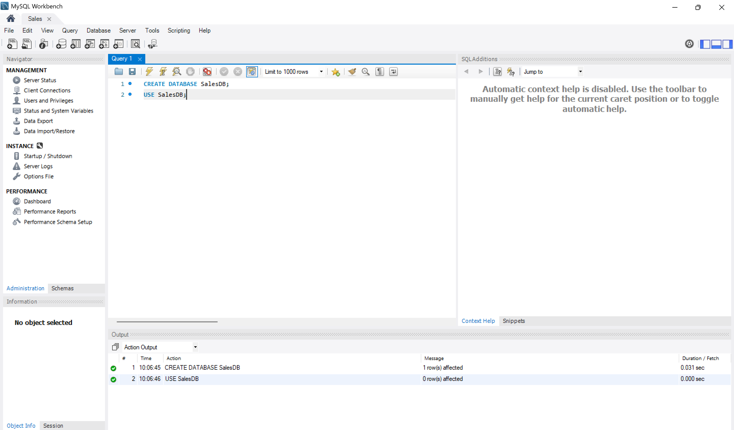
Step 2: Create Table
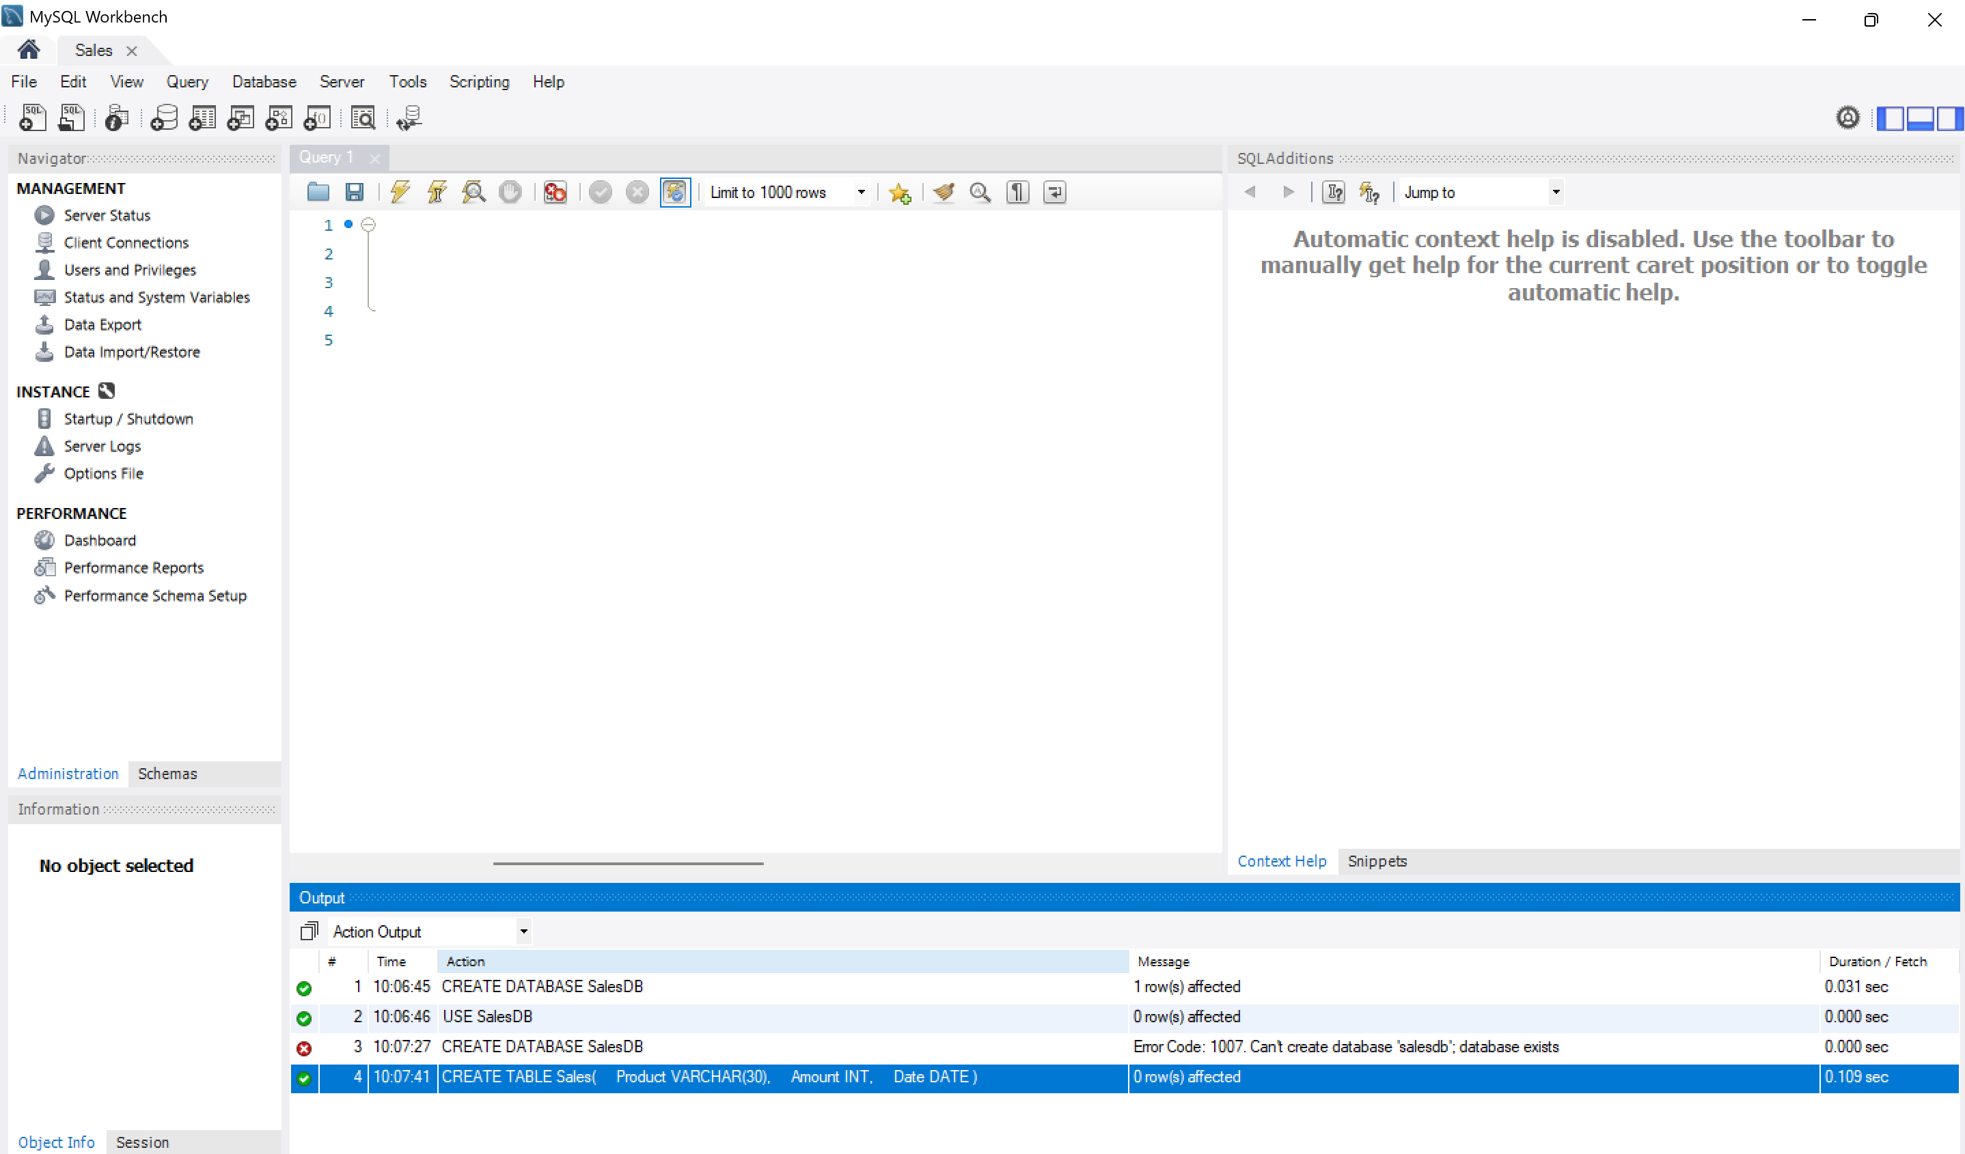

Step 3: Insert Sample Data
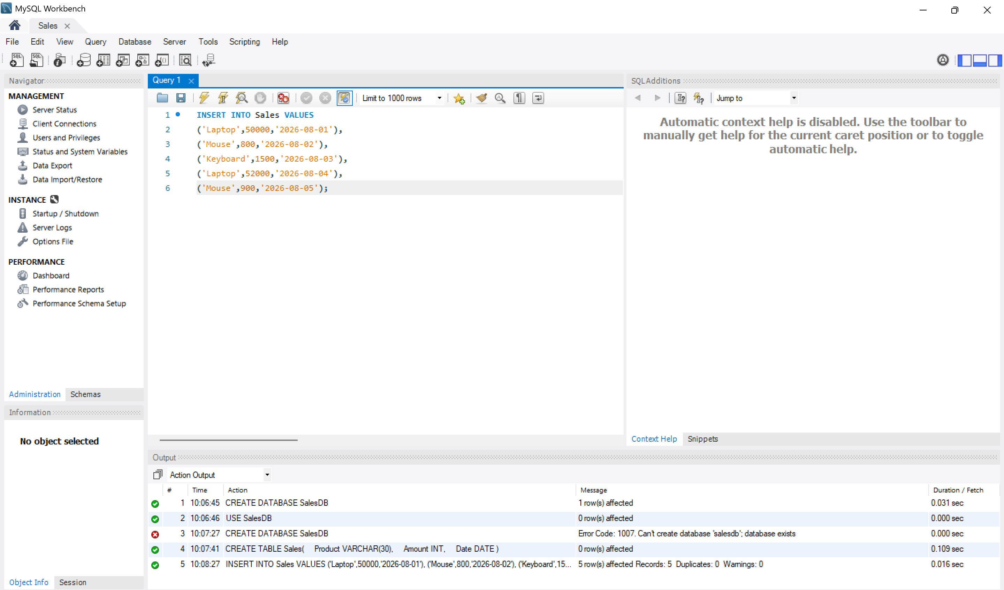
Query 1: COUNT()
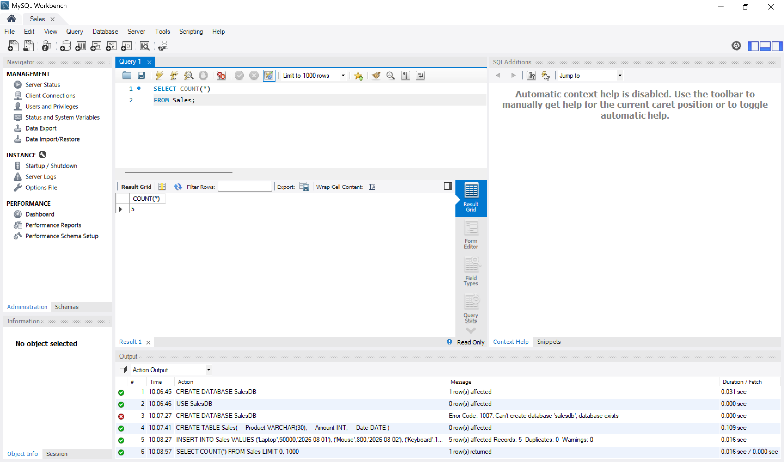
Output: Total number of rows.

Query 2: SUM()
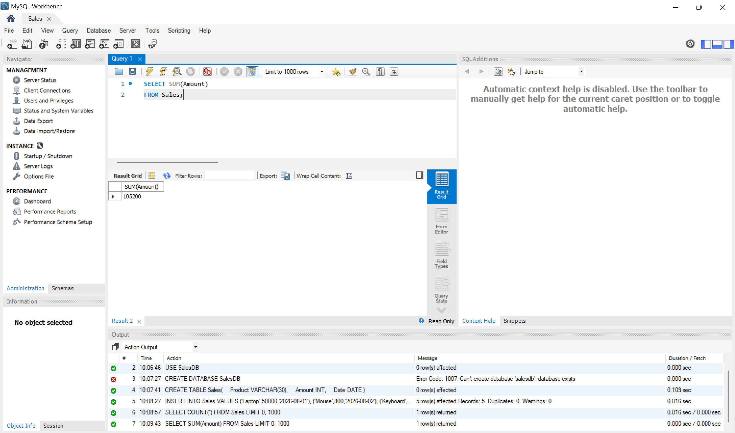
Output: Total sales amount.
Query 3: AVG()
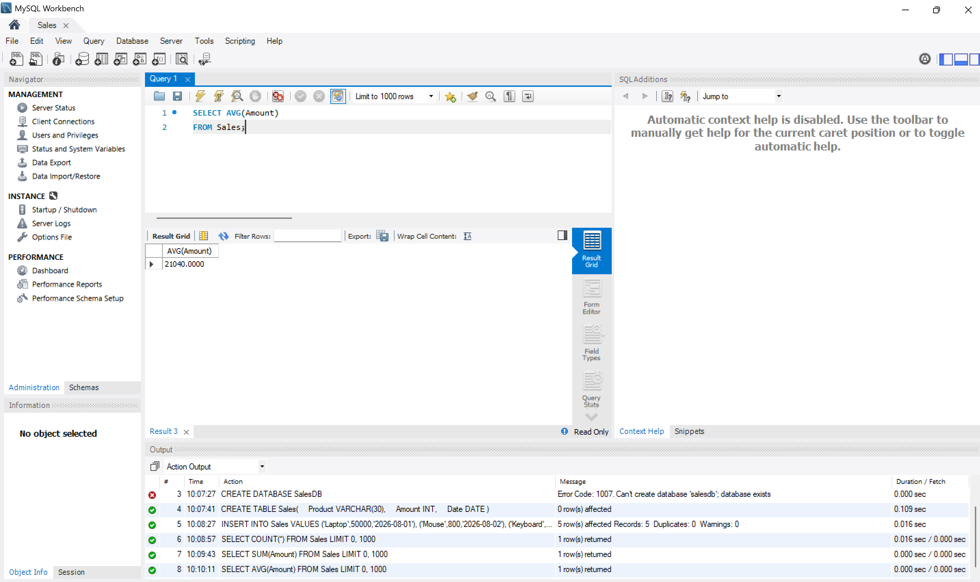
Output: Average sales amount.
Query 4: MIN() and MAX()
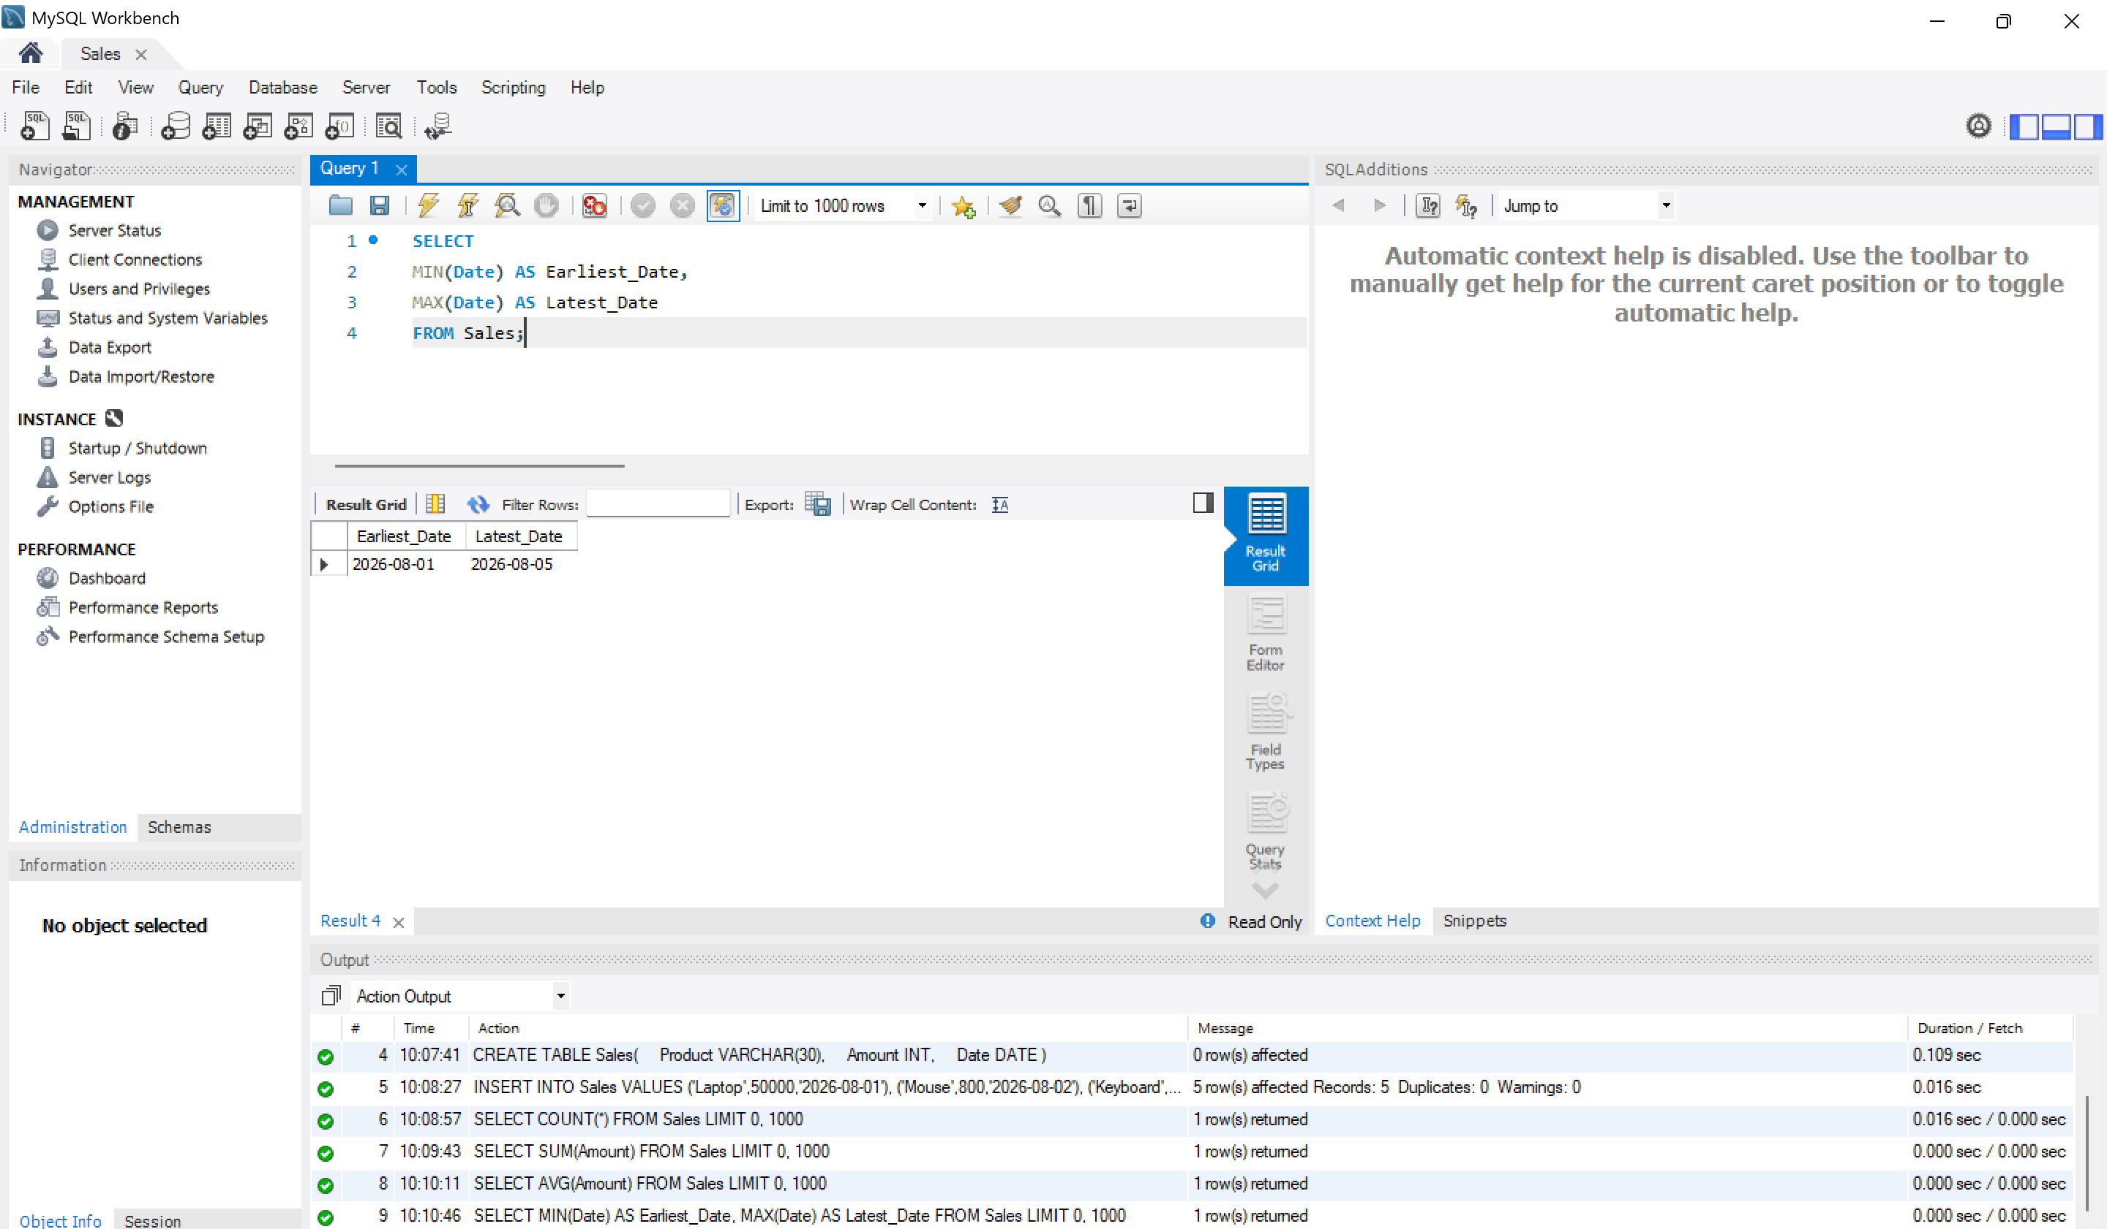
Query 5: GROUP BY
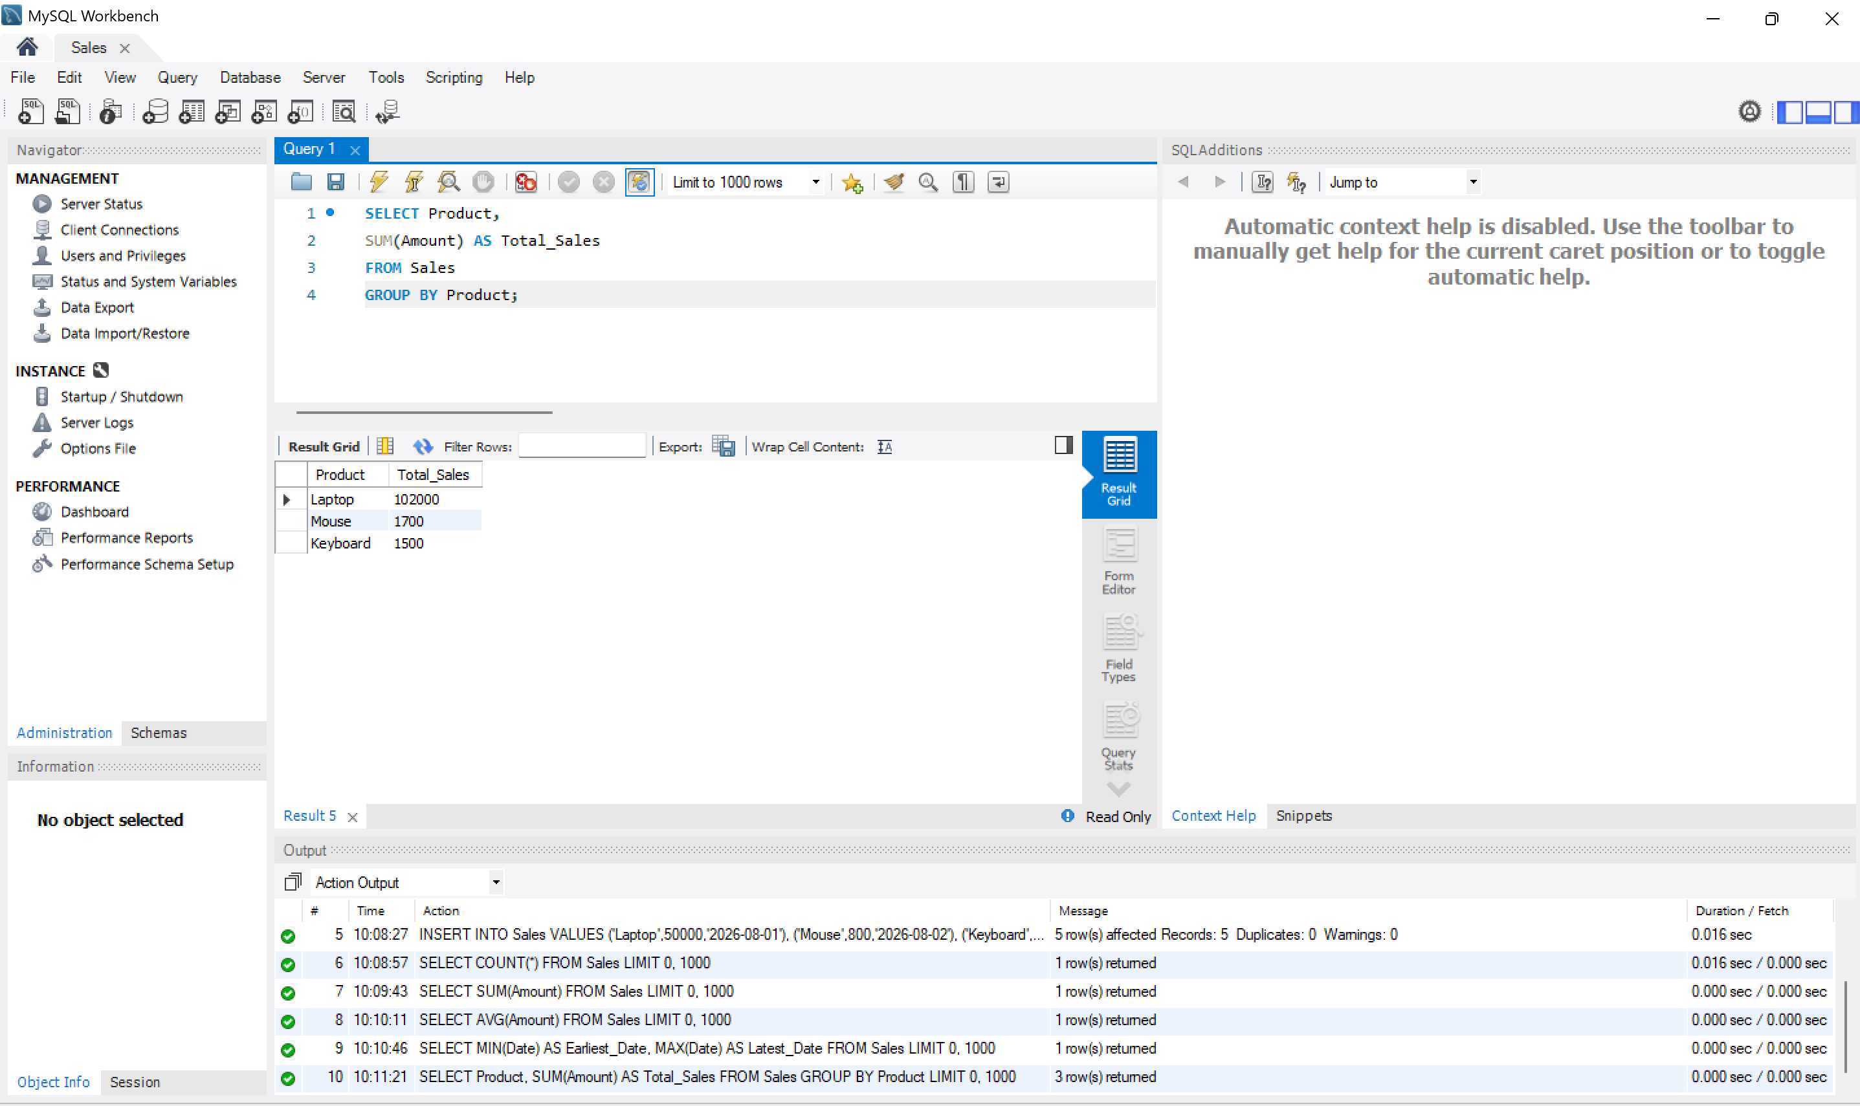

Query 6: ORDER BY
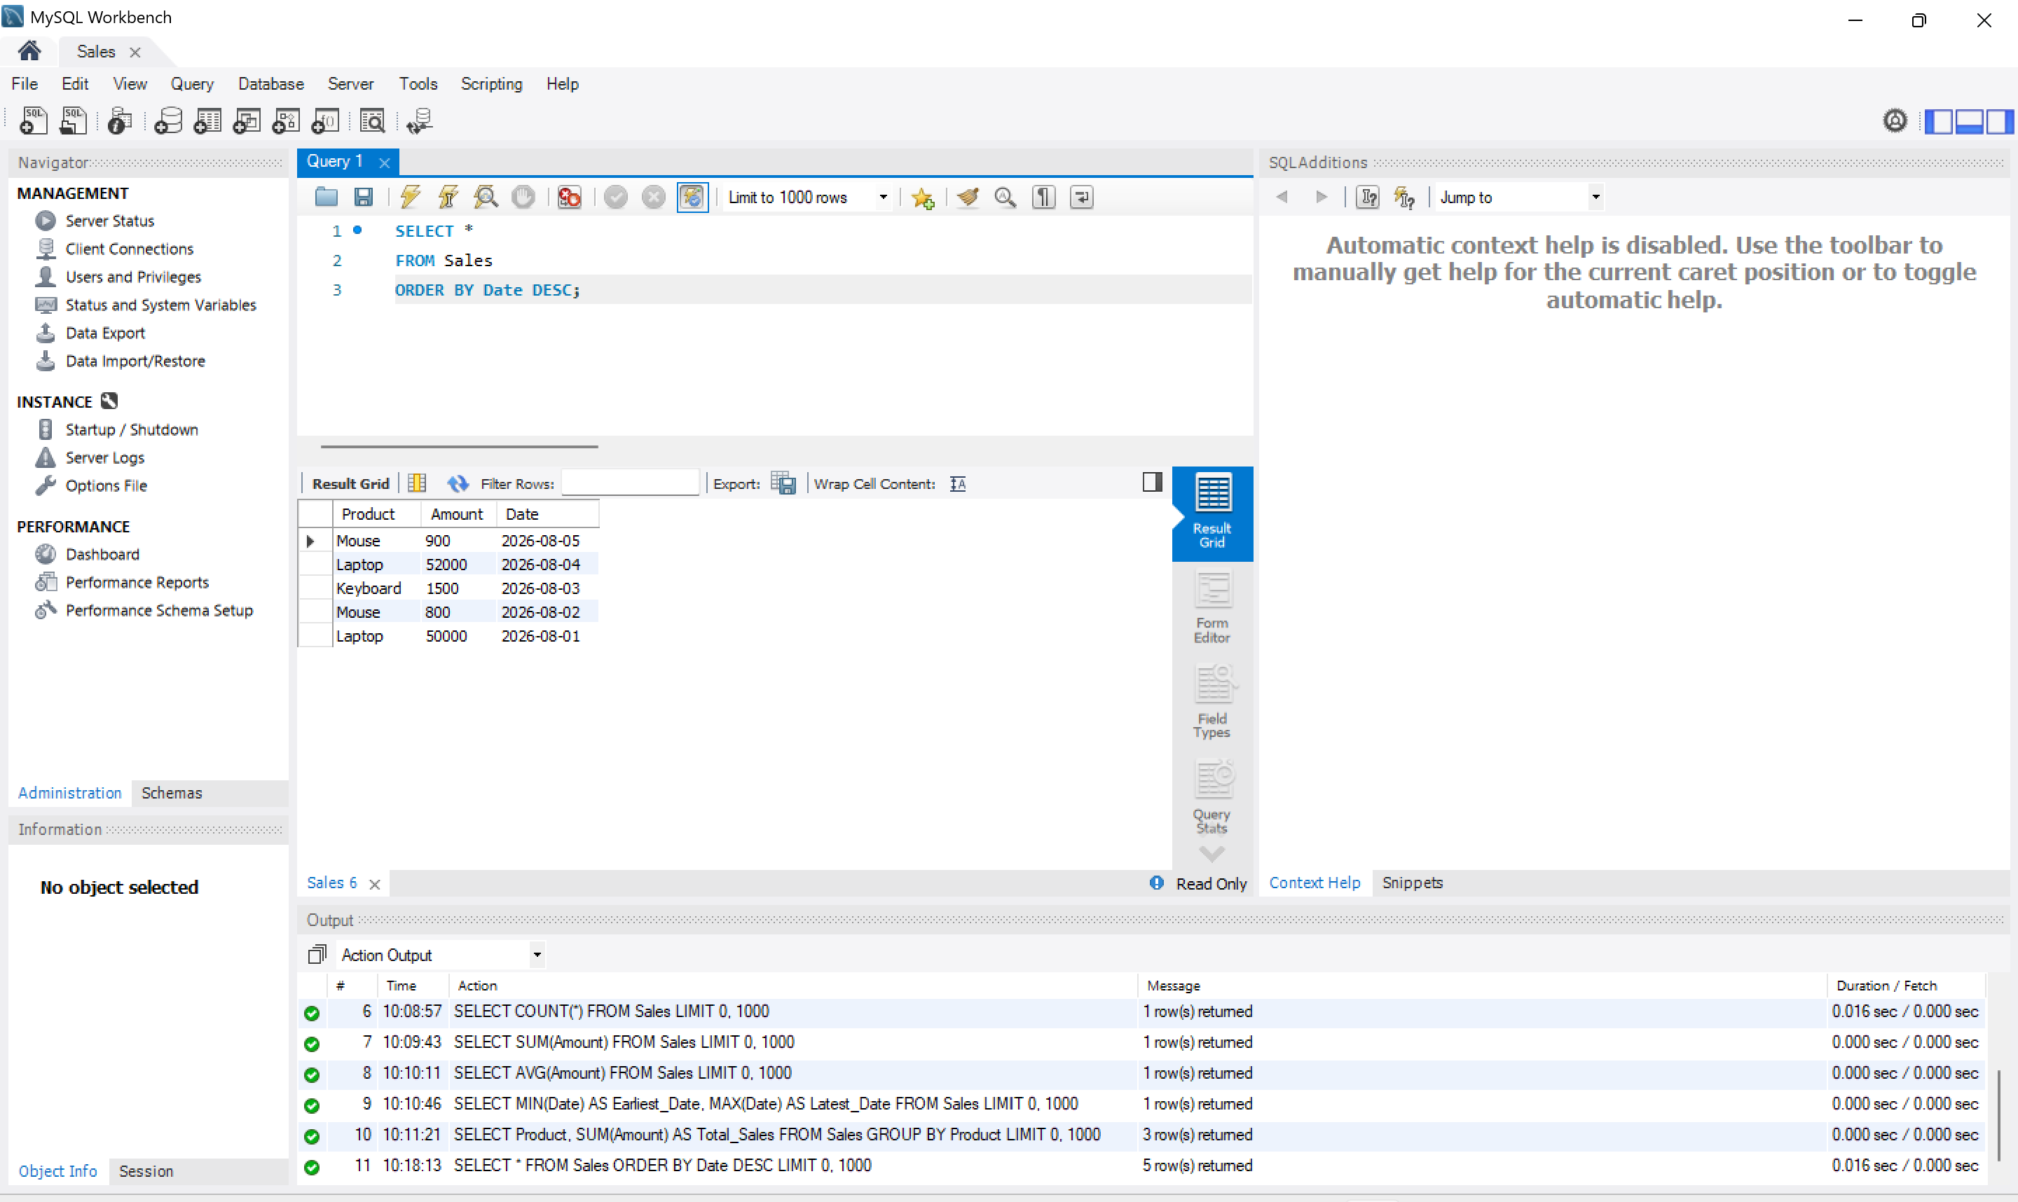

JOINING NUMEROUS DATASETS
Step 1: Create Database
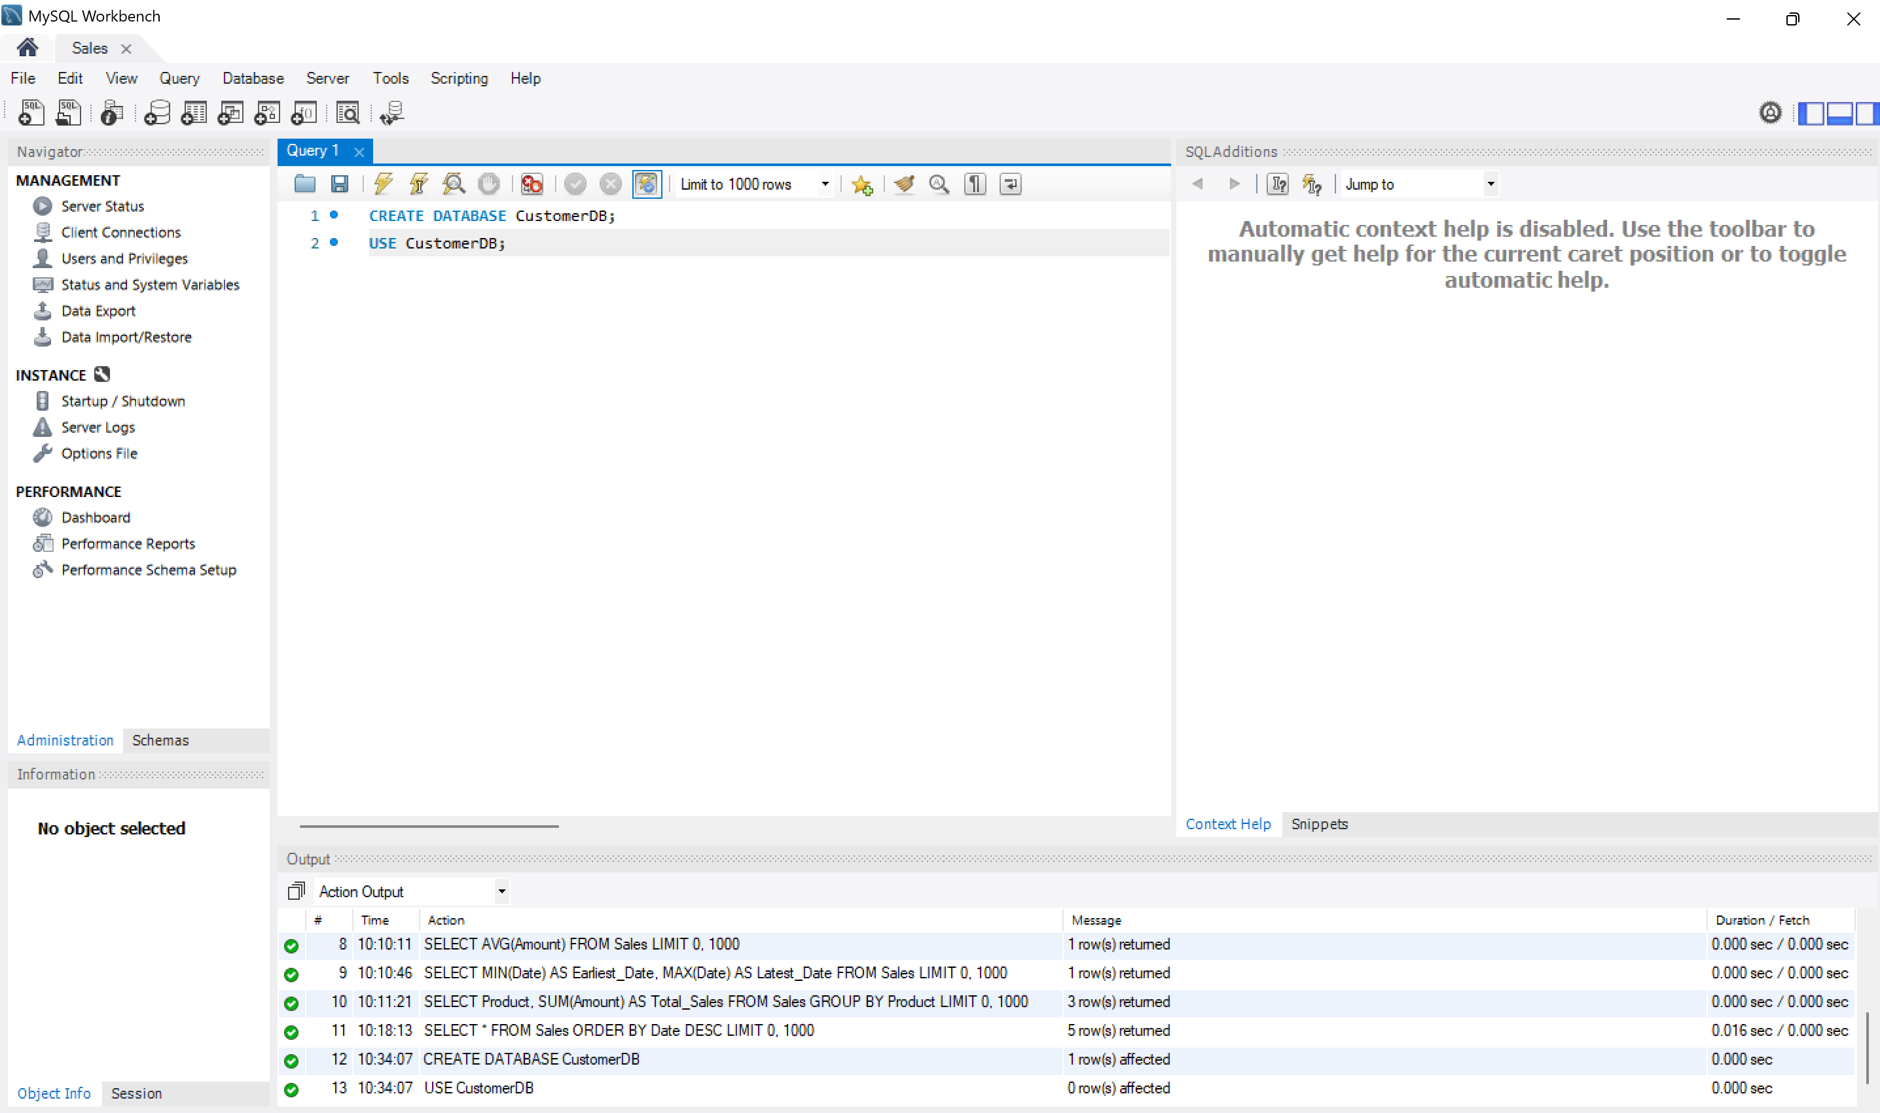
Step 2: Create Customers Table
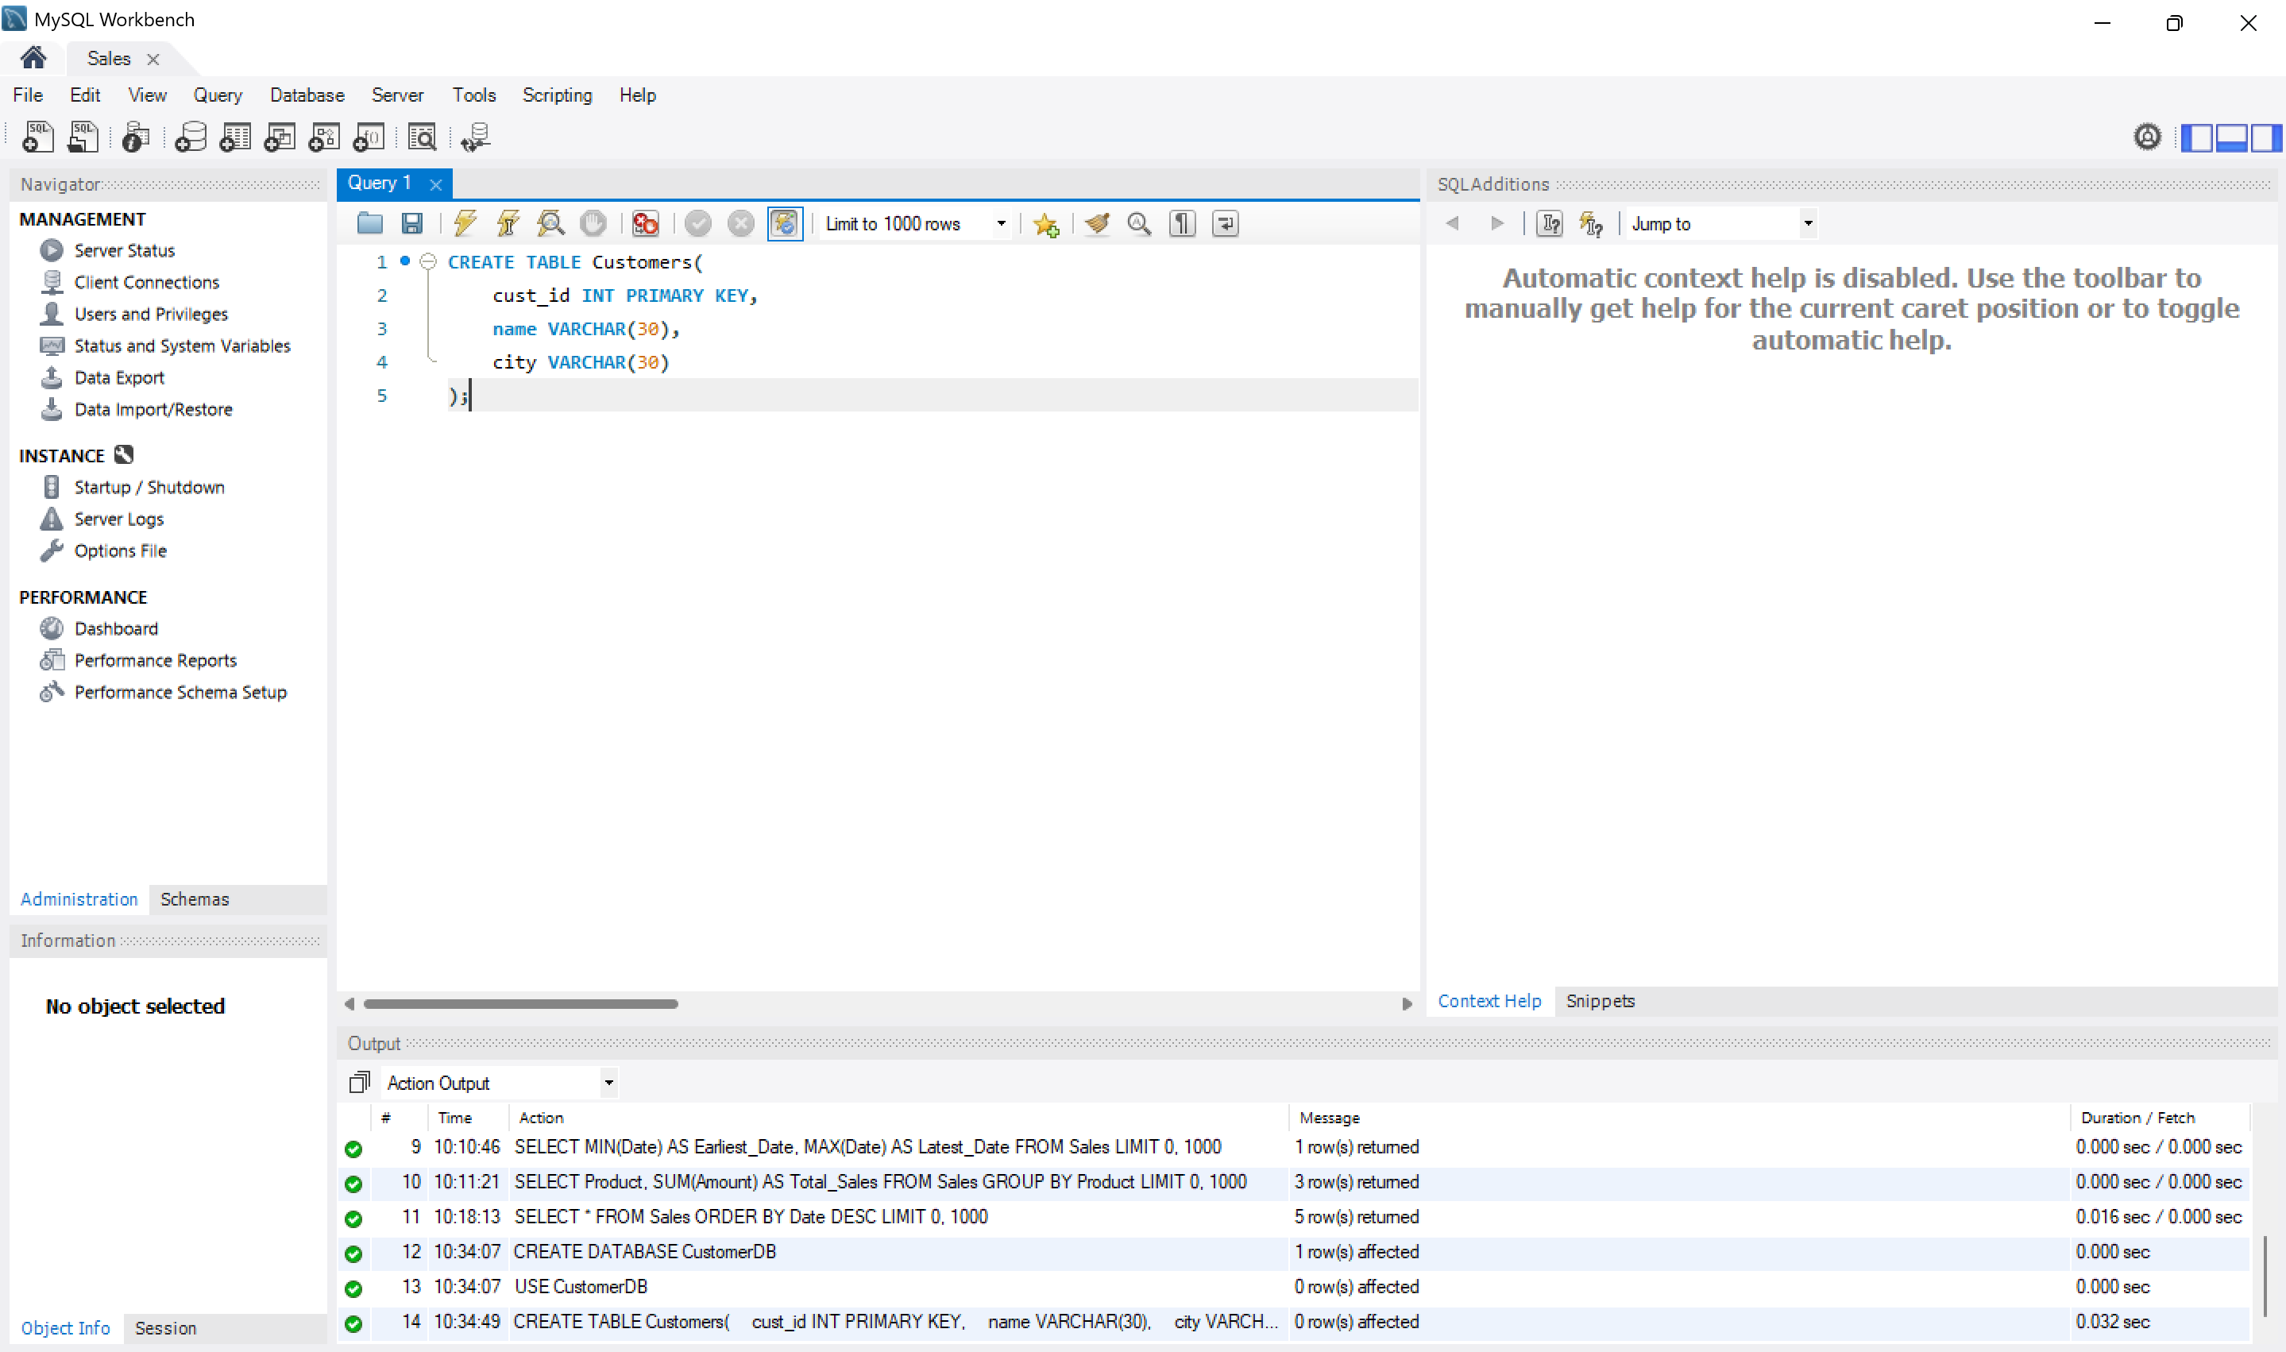

Step 3: Create Orders Table
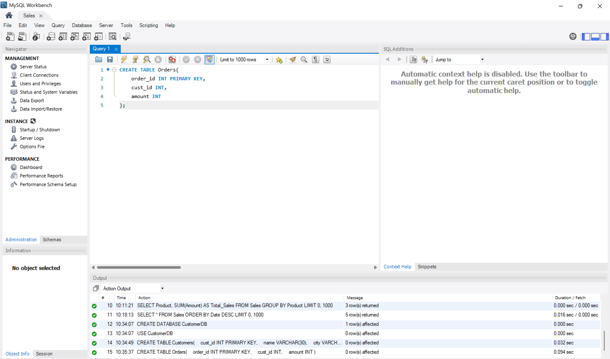
Step 4: Insert Data
Customers
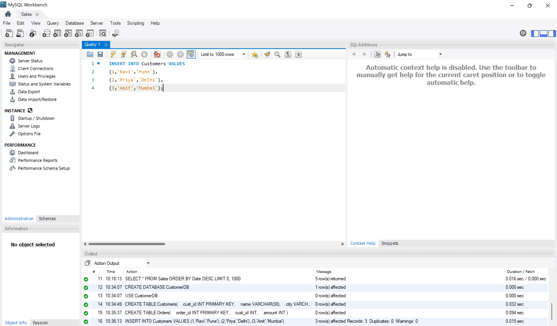
Orders
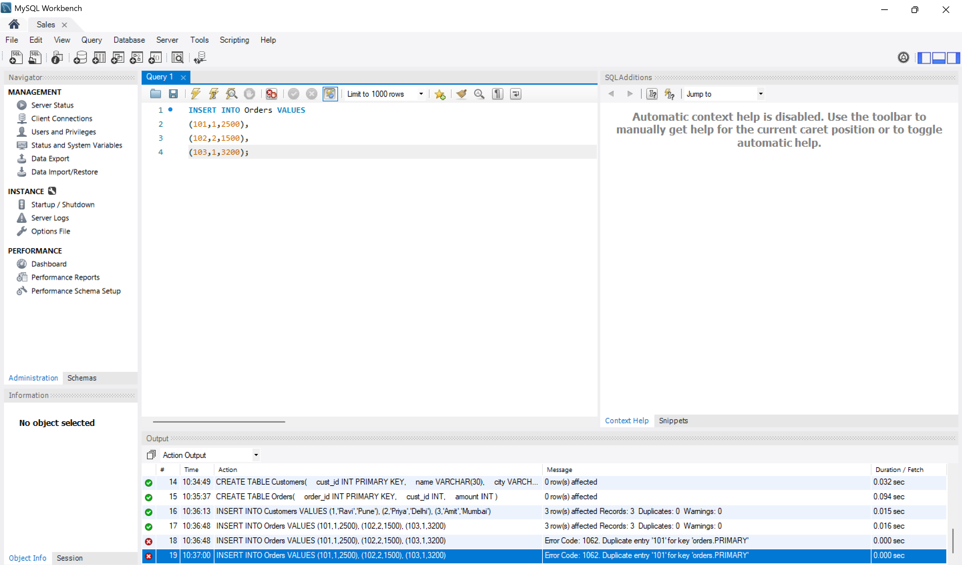
INNER JOIN
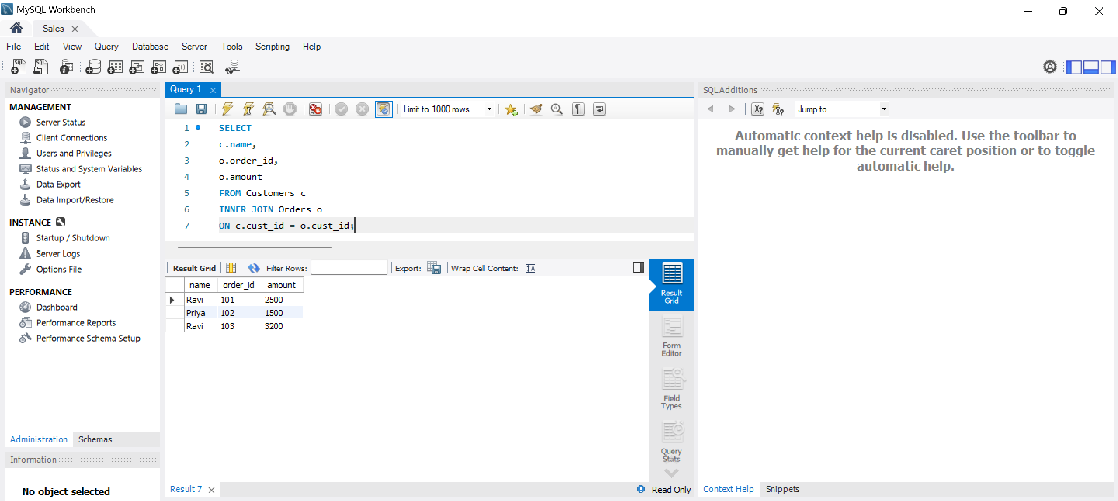

LEFT JOIN
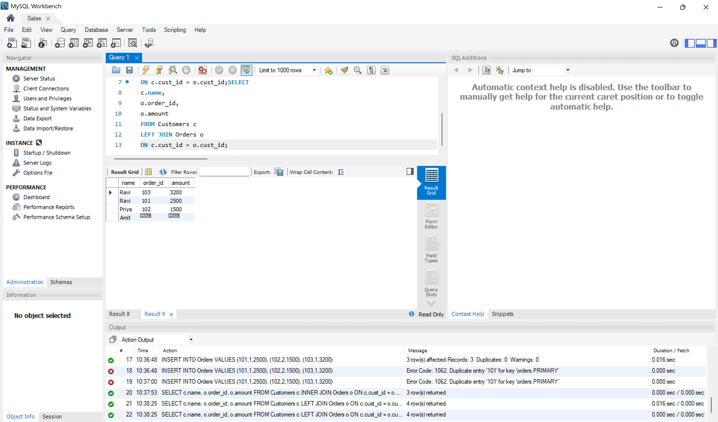
RIGHT JOIN
